
Cosmetology
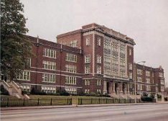

Welcome to the world of professional Cosmetology. Our Cosmetology program is a 2 -year program.
Junior and Senior Year
- Good Attendance Mandatory
- 1,220 hours Required Missouri State board of Cosmetology.
With the completion of a sequence of classes, you will have the skills necessary to obtain a Cosmetology License through Missouri State Board of Cosmetology and Barbering.
We explore every facet of the fundamentals of Cosmetology, as well as learn the vital practice of Professional Ethics and Entrepreneurship. 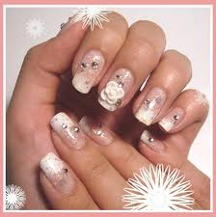

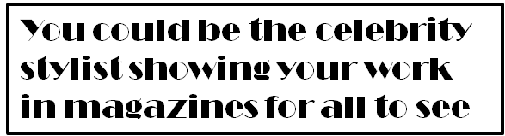
St. Louis Public Schools

Division of Career and Technical Education
Teacher’s
Ms. Sonya Sanders
&
Mrs. Laketria Williams


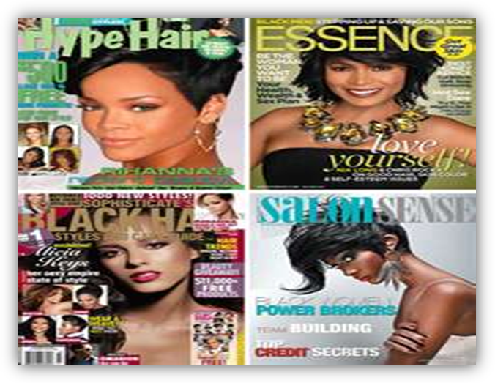
Beaumont Technical Center
3836 Natural Bridge Avenue
St. Louis, MO 63107
314-533-2410

Dr. Felita Williams
Principal
Responsibility, Choices, Consequences.

610 hours LEVEL I - First Year
Teaching the Basics
Introduction to Cosmetology and Beauty Culture Industry
Professional Image and Hygiene
Salon Safety and OSHA standards
Bacteriology, Sanitation and Sterilization, Electricity, Anatomy and Physiology
Preparation of a Client for various services, Shampooing the Hair
Hairstyling - Roller Setting, Pin Curls, Blow Dryer and Curling Iron Techniques, Braiding
Scalp Treatment, Facial, Arching Eyebrows, Applying Make-up
Basic Manicuring, Arm and Hand Massage
Permanent Waving
Hair-coloring using Rinses, Semi-permanent and Permanent Hair Color, Lightening Techniques
Basic Hair-cutting

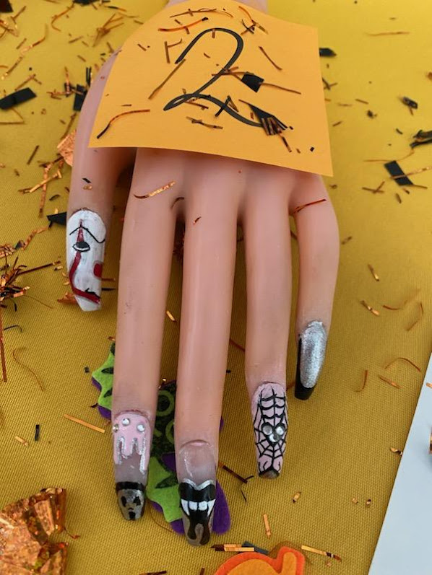
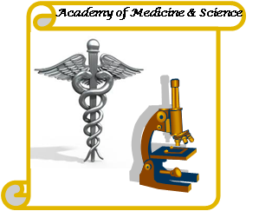

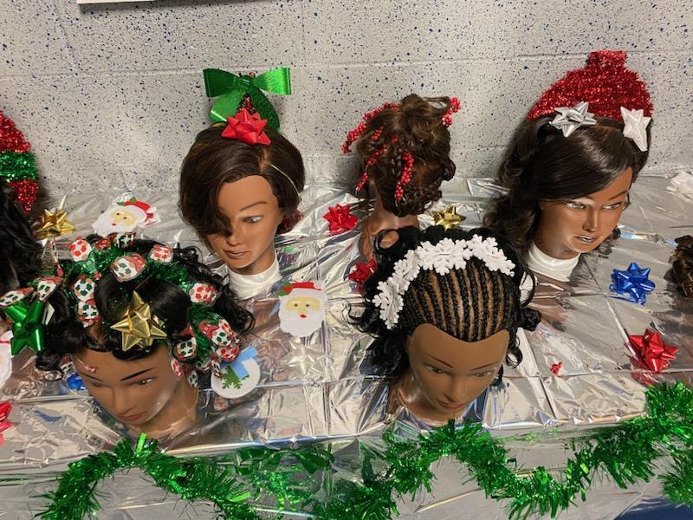

Christmas Hair Style’s
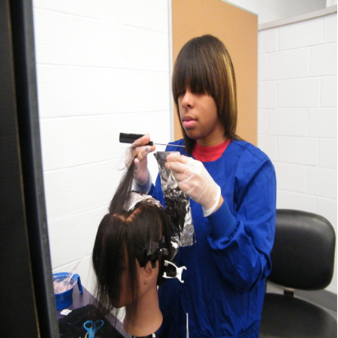
Foil Highlight Application

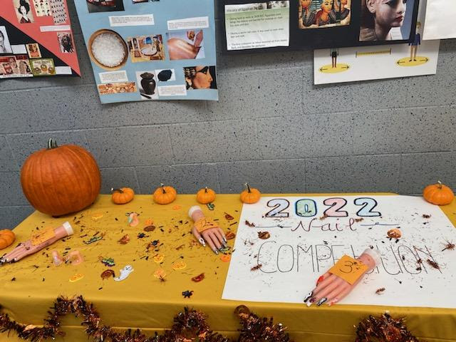
610 hoursLevel II - Second Year
Review from First Year and More In-Depth Techniques
Advanced Hairstyling, Blow Drying, Roller Setting, Updos, French Twist,
Finger Wave, Specialty Scalp Treatments, Facials- Masks, Waxes
Manicuring, Gel nails, Nail tips, Nail repairs
Men’s manicure, Pedicures
Give a Special Permanent Wave Wrap, Soft Waves
Relaxers - Sodium Hydroxide and Thio Relaxer
Basic and Advanced Hair-cutting Techniques and Styles, Cutting Bangs, Angles
Clipper-Cutting, Men’s Hair-cutting
Advanced Lightening Techniques with Different Products
Review, Some New Items, Getting Ready for the State Board Exam
Mock Boards
Hairstyling - Styling a Wiglet, Extensions, Permanent Waving,
Hair Coloring, Back Massage
Salon Management
Total required hours 1220

Halloween Nail’s

